STRUCTURAL AND MATERIAL ANALYSIS OF

TWIN ROTOR MIMO SYSTEM

A PROJECT REPORT

Submitted by

KAMAL KUMAR D - RA1411002010036

HASWANTH M - RA1411002010174

DHINESHWARAN V - RA1411002010064

Under the guidance of
MR.VAMSI DOMMETI KRISHNA., M.Tech.
(Assistant Professor (O.G), School of Mechanical Engineering)

DEPARTMENT OF MECHANICAL ENGINEERING

FACULTY OF ENGINEERING & TECHNOLOGY


S.R.M. Nagar, Kattankulathur, Kancheepuram District
MAY 2017

SRM UNIVERSITY
(Under Section 3 of UGC Act, 1956)

BONAFIDE CERTIFICATE

Certified that this minor project report titled “STRUCTURAL AND MATERIAL ANALYSIS OF TWIN ROTOR MULTIPLE INPUT MULTIPLE OUTPUT () SYSTEM" is the bonafide work of “KAMAL KUMAR D (RA1411002010036), HASWANTH M (RA1411002010174) , DHINESHWARAN V (RA1411002010064)”, who carried out the minor project work under my supervision. Certified further, that to the best of my knowledge the work reported herein does not form any other project report or dissertation on the basis of which a degree or award was conferred on an earlier occasion on these or any other candidate.

SIGNATURE SIGNATURE

MR.VAMSI KRISHNA D., MTech. DR.HARIDASAN
GUIDE HEAD OF THE DEPARTMENT Assistant Professor (O.G) of Mechanical Engg. Department of Mechanical Engineering

Signature of the Examiner-I Signature of the Examiner -II

CHAPTER NO. TITLE PAGE NO.

ACKNOWLEDGEMENT………………………………………………………………5
ABSTRACT……………………………………………………………………………...6
LIST OF TABLES………………………………………………………………………7
LIST OF FIGURES……………………………………………………………………. 8
1. INTRODUCTION…………………………………………………………….9
1.1 Twin rotor MIMO system……………………………………………………...9
1.2 Model…………....………………………………………………….................11
1.3 Principles……………………………………………………………………....11
1.4 Concepts…...………………………………………………..………………...12
1.5 Reason for analysis…………………………………………...……………….14
2. LITERATURE REVIEW…………………………………..……………….16
3. MODELING…………………………………………………..……………..18
3.1 Solid works……………………………………………………..…………….18
3.2 Creating a part and drawing……………………………………..……………18
3.3 Modeling methodology………………………………………….…………...19
3.4 Changing views…………………………………………………….………...20
3.5 File format…………………………………………………………….……...20
3.6 Solid works model……………………………………………………..…......21
4. ANALYSIS…………………………………………………………….…....24
4.1 Ansys……………………………………………………………………...…24
4.2 Material Properties………………………………………………………….24
4.3 Element type……………………………………………………………......25
4.4 Static Analysis……………………………………………………………...26
4.5 Meshing using hupermesh………………………………………………….28
4.6 Structural analysis………………………………………………………….29
5. RESULTS………………………………………………………………….38
5.1 Structural analysis of Stainless steel……………………………………….38
5.2 Structural analysis of Aluminium………………………………………….38
5.3 Structural analysis of Titanium…………………………………………….38
5.4 Structural deflection of Kevlar…………………………………………….38
6. CONCLUSION…………………………………………………………...39
7. REFERENCE…………………………………………………………….40

ACKNOWLEDGEMENT

We take this opportunity to express a deep sense of gratitude to the department of Mechanical Engineering, SRM University for providing us the opportunity to work on this project as a team.

We also take this opportunity to express my profound gratitude and deep regards to my guide Vamsi Dommeti Krishna.D., Assistant professor (O.G) for his exemplary guidance, monitoring, constant encouragement throughout the completion of this project.

We also express our sincere thanks to Dr. Haridasan head of the department of mechanical engineering for giving us an opportunity to complete this project work.

We thank all our department staff who stood by us in every means to finish this project successfully. A special thanks to our friends who supported us to finish this project.

ABSTRACT

This project aims in designing and developing a discrete model of Twin Rotor Multi Input and Multi Output System (TRMS) at low cost. The TRMS is a laboratory model of a helicopter that mimics the dynamics of its design. The mechanical modelling of the TRMS was designed in MATLAB and simulated. Following a complete analysis of previous designs, we have come up with a model of TRMS that has modular mechanical structure. This modular design, unlike its precedents, gives us the flexibility of rearranging the geometry of the entire TRMS so as to achieve an accurate analogous model of a helicopter. The flexibility of system design helps to redefine the physical model of the TRMS to mime any commercially available helicopters, and by doing so, improving the quality of the controller designed. This project is focused on improving the controllability of the helicopters during its state of hovering and fine maneuvering.

Key words: TRMS, helicopter, Hovering, controller.

LIST OF TABLES

TABLE NO. TITLE PAGE NO.
Table-1 Material Properties 24
Table-2 Element type 25
Table-3 Result 38

LIST OF FIGURES

NUMBER TITLE PAGE NO.
Figure-1 TRMS front view 10
Figure-2 TRMS isometric view 10
Figure-3 Gyroscope 12
Figure-4 Various degrees of motion 13
Figure-5 Various motions of Helicopter 13
Figure-6 TRMS assembly 21
Figure-7 TRMS rod 22
Figure-8 Bearing 22
Figure-9 Hyper mesh auto mesh panel 27
Figure-10 Tetra mesh panel 27
Figure-11 Deflection of Aluminium material 29
Figure-12 Shear stress XY for Aluminium 29
Figure-13 Stress Y for Aluminium 30
Figure-14 von mises Stress Y for Aluminium 30
Figure-15 Deflection of Stainless Steel material 31
Figure-16 Shear Stress XY for Stainless Steel 31
Figure-17 Stress Y for Stainless Steel 32
Figure-18 von mises Stress for Stainless Steel 32

CHAPTER 1

INTRODUCTION

A helicopter is a type of rotorcraft in which lift and thrust are supplied by rotors. This allows the helicopter to take off and land vertically, to hover, and to fly forward, backward, and laterally. These attributes allow helicopters to be used in congested or isolated areas where fixed-wing aircraft and many forms of VTOL (vertical takeoff and landing) aircraft cannot perform.
Tandem rotor helicopters are also in widespread use due to their greater payload capacity. Coaxial helicopters, tiltrotor aircraft, and compound helicopters are all flying today.

  - TWIN ROTOR MIMO SYSTEM

A photograph of the Twin Rotor MIMO System is presented in Fig. 1. The system is used to demonstrate the principles of a non-linear MIMO system, with significant cross-coupling. Its behavior resembles a helicopter but contrary to most flying helicopters the angle of attack of the rotors is fixed and the aerodynamic forces are controlled by varying the speeds of the motors. Significant cross-coupling is observed between the actions of the rotors, with each rotor influencing both angle positions. Aspects of the plant behavior are similar to flying helicopters. There are two propellers driven by DC-motors at both ends of a beam, which is pivoting on its base. The joint allows the beam to rotate in such a way that its ends move on spherical surfaces. The controls of the system are the motors supply voltages. The measured signals are position of the beam in the space, i.e. two position angles. The system showcases 2-DOF model of a helicopter. The project briefly explains on the static balancing of the TRMS model using analytical and mechanical calculations.

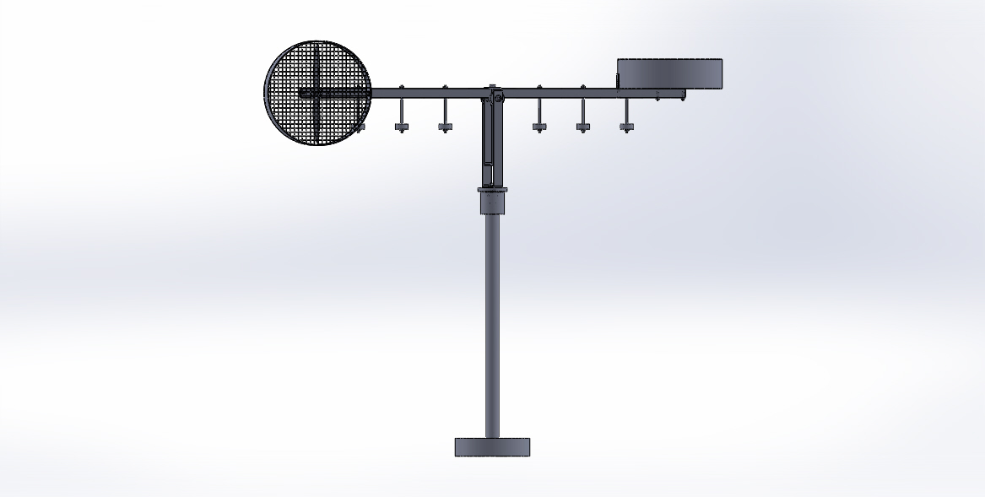
Figure-1: TRMS front view

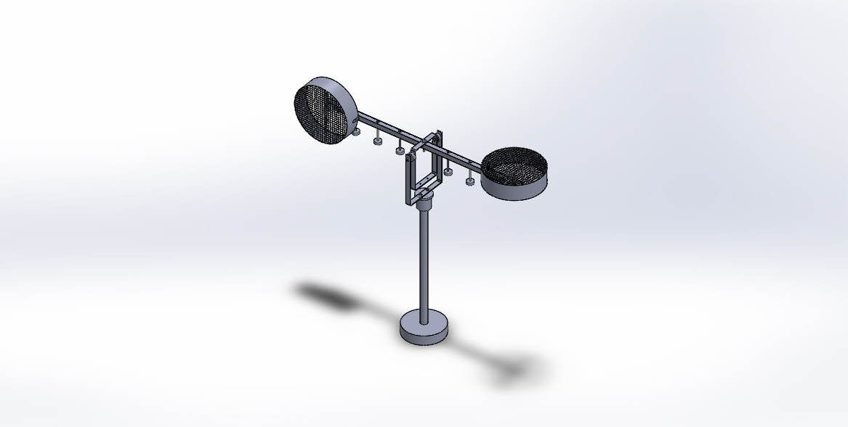
Figure-2: TRMS isometric view

  - MODEL

Our model depicts the nature of a twin rotor system (helicopter). There are three degrees of freedom, out of which our model illustrates two degrees of freedom namely, Pitch and Yaw motion. This concept is achieved using three ball bearings, one for yaw and the rest two for pitch motion. It is equipped with two rotors (BLDC motors). The one in the front position is in-line and the rear motor which resembles the tail rotor of the helicopter is eccentrically placed. The body of the TRMS is prototyped as a Hollow square beam of length 1060mm and hollow section of dimension 25*25 mm with thickness 1mm. We felt that the basic requirement was the study of its structural and material properties. Weight loading is done using weight hangers which are equidistant from each other in the context of loading and not physically.

  - PRINCIPLE

Gyroscope works on the principle that angular momentum changes in the
direction of Torque. Useful for measuring or maintaining orientation. Applications of gyroscopes include inertial navigation systems where magnetic compasses would not work, as in the Hubble telescope, or inside the steel hull of a submerged submarine, or would not be precise enough. Due to their precision, gyroscopes are also used in gyro theodolites to maintain direction in tunnel mining. Gyroscopes can be used to construct gyrocompasses, which complement or replace magnetic compasses (in ships, aircraft and spacecraft, vehicles in general), to assist in stability (Hubble Space Telescope, bicycles, motorcycles, and ships) or be used as part of an inertial guidance system.

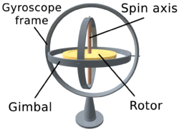
Figure-3 : Gyroscope
Gyroscope precession is the resultant action or deflection of a spinning object when a force is applied to this object. This action occurs approximately 90 degree in the direction of rotation from the point where the force is applied.
1.4. CONCEPTS

Angular momentum: The definition of angular momentum for a point particle is
a pseudovector r×p, the cross product of the particle's position vector r (relative to some
origin) and its momentum vector p = mv.
Moment of inertia: The moment of inertia, otherwise known as the angular
mass or rotational inertia, of a rigid body is a tensor that determines the torque needed for
a desired angular acceleration about a rotational axis.
Newtons second law: In an inertial reference frame, the vector sum of the forces F on an
object is equal to the mass m of that object multiplied by the acceleration a of the
object: F = ma.
Torque: Torque, moment, or moment of force is the tendency of a force to rotate an object
around an axis, fulcrum, or pivot.
Aero foil theory: A fluid flowing past the surface of a body exerts a force on it. Lift is
the component of this force that is perpendicular to the oncoming flow direction. It
contrasts with the drag force, which is the component of the surface force parallel to the
flow direction.
Thrust: The force applied on a surface in a direction perpendicular or normal to the surface is called thrust.
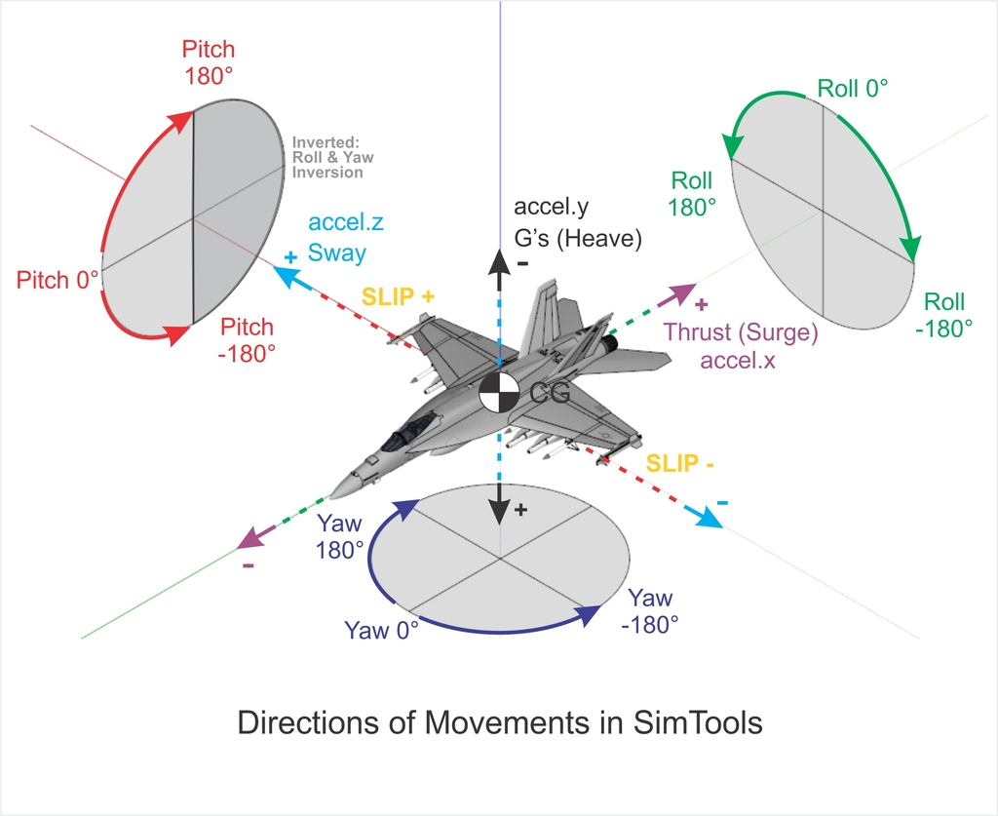
Figure–4 : Various degrees of motion.

The figure below describes various motion with respect to direction. The image also illustrates the degrees of freedom under consideration.

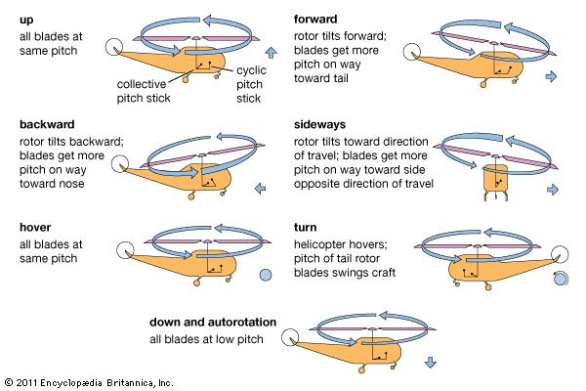
Figure-5: Various motions of Helicopter.

Normally, weight is thought of as being a known, fixed value, such as the weight of the helicopter, fuel, and occupants. To lift the helicopter off the ground vertically, the rotor system must generate enough lift to overcome or offset the total weight of the helicopter. Newton’s first law-Every object in a state of uniform motion tends to remain in that state of motion unless an external force is applied to it. In this case the object is the helicopter whether at a hover or on the ground and external force applied to it is lift which is accomplished by increasing the pitch angle of the main rotor blades. This action forces the helicopter would either remain on the ground or at a hover. The weight of the helicopter can also be influenced by aerodynamic loads. When you bank a helicopter while maintaining a constant altitude, the load factor increases. Any time a helicopter flies in a constant altitude curved flightpath, the load supported by the rotor blades is greater than the total weight of the helicopter.

1.5. REASON FOR ANALYSIS

The current system is termed to be front loaded, there is the first instance of a question “why front loading?” The solution to this question could only be resolved via analysis of various loading condition. The second question that comes in is regarding the structure of the helicopter and its dimensions. This is solved by studying its structure and try a prototype in order to simulate the working of the helicopter. Various other reasons to analysis this TRMS is to study loading at different positions, variation due to different magnitudes of force (load) , various cross sectional study, various dimensional understanding and various terms related to structural analysis of a mechanical component such as stress, strain, deflection, shear, fatigue strength, vibrational effect and moment concepts.
There is an ideology behind doing an analysis that the results obtained analytically and mechanically are to be related, i.e. related maximum of 5-10 % error is sometimes legit as per conclusions and approximations.
Through analysis one could easily understand the changes that are expected to happen in real life situation rather than fabricating the whole setup and the checking for results which proves expensive.
Analysis software used in this project is ANSYS APDL 16.0. The software that is used for making the whole assembly is SOLIDWORKS 2014. The software that is used for Meshing is HYPERMESH 13.0.

CHAPTER 2

LITERATURE REVIEW

“Modelling of Twin Rotor MIMO System - Petr Chalupa, Jan Přikryl and Jakub Novák” paper deals with modelling of a Twin Rotor MIMO System – a laboratory model constructed by Feedback Instruments Ltd. The system consists of two rotors which resembles a simple helicopter. The non-stationary part of the model can rotate around two perpendicular axes to produce azimuth and elevation output of the system. These outputs are affected by speed of the rotors. Significant cross-coupling can be observed and the system behavior is nonlinear. A model based on first–principle modelling was derived and is parameters were refined by identification based on real-time experiments. Resulting model was designed in MATLAB/Simulink environment and can serve for control design.

“Non-linear modeling and PID control of twin rotor MIMO system- A. P. S. Ramalakshmi and P.S. Manoharan” paper deals with PID control tuning for a nonlinear multi-input multi-output system (MIMO). In this paper, a laboratory helicopter model called the twin rotor MIMO system (TRMS) is considered as a MIMO system. The mathematical modeling of helicopter model is simulated using MATLAB/Simulink for controlling it. The two degrees of freedom (2-DOF) are controlled both in horizontal and vertical direction using proportional-integral-derivative (PID) controller. Simulation results are obtained for different input signals. Moreover the error of the plant output and control output of PID controller are presented which show the performance evaluation of TRMS.

“Control of twin rotor MIMO system using PID controller with derivative filter coefficient- Sumit Kumar Pandey and Vijaya Lakshmi” paper presents a proportional integral derivative (PID) controller with a derivative filter coefficient to control a twin rotor multiple input multiple output system (TRMS), which is a nonlinear system with two degrees of freedom and cross couplings. The mathematical modeling of TRMS is done using MATLAB/Simulink. The simulation results are compared with the results of conventional PID controller. The results of proposed PID controller with derivative filter shows better transient and steady state response as compared to conventional PID controller.

The mechanical domain in this project was found to be unexplored. Our project basically satisfies that need to some extent. The documents explained about current systems design and electronic domain projects.

CHAPTER 3
MODELING
3.1 SOLIDWORKS
Solid works is a solid modeling computer aided design and computer aided engineering software program that runs on Microsoft Windows is produced by the DASSAULT SYSTEMS a subsidiary of Dassault Systems, S. A. base in Velizy, France since 1997
Solid works is currently used by over 2 million engineers and designers at more than 165,000 companies worldwide. In 2011-12, the fiscal revenue for SolidWorks was reported $483 million.
3.2 CREATING A PART AND DRAWING
When SolidWorks is first opened, you have to open a part, assembly or drawing. When a new part is opened, there is a blank work area on the right and a column on the left called the feature manager. In the feature manager, there are the three main planes listed – front, top and right. to begin a sketch, a plane to draw on must be selected. Right click on the desired plane and select the sketch the sketch icon in the fly-out menu. For the first sketch the view will rotate so that you are looking perpendicular to the plane you selected.
The first feature sketched is called the base feature. Added on feature are called boss or cut features. These add or subtracted material to create the part. It is best to keep the geometry of each feature as simple as possible. Create a part with a large number of simple features rather than a few complex ones. Your work will be much easier to perform and less prone to errors in the long run.
Plan how the part is going to be used before beginning the sketch. Which faces do you want for the front, top and right views? Where do you want the origin to be? It is easier to take a few minutes and plan ahead than to have to redo a part because the wrong orientation was used. A quick hand sketch on a sheet of paper to determine the final appearance can save a lot of effort and time. A good habit to get into is to place the origin on a plane of symmetry if there is one. This will save you a lot of work in creating a part.
Try to use the geometric relations as much as possible to orient a new feature to a previous feature. Thus, if the first feature as much as possible to orient a new feature to a previous feature. Thus, if the first feature is changed, the second feature will follow along with it rather than having to be re-dimensioned. Solid works is a parametric program, which means that the dimension drive the size and shape of the part rather than the reverse. The benefit of this is that redraw the part. Careful selections of the geometric relations and dimensions can simplify the task.

3.3 MODELING METHODOLOGY
Solid works is a solid modeler, and utilizes a parametric feature based approach to create models and assemblies. The software is written on Parasolid-kernel.
Parameters refer to constrains whose valves determine the shape or geometry of the model or assembly. Parameters can be either numeric parameters, such as line lengths or circle diameters, or geometric parameters, such as tangent, parallel, concentric, horizontal or vertical, etc. numeric parameters can be associated with each other through the use of relations, which allows them to capture design intent.
Design intent is how the creator of the part wants it to respond to changes and updates. For example, you would want the hole at the top of a beverage can to stay at the top surface, regardless of the height or size of the can. Solid works allows the user to specify that the hole is a feature on the top surface, and will then honor their design intent no matter what height they later assign to the can.
The first feature sketched is called the base feature. Added on features are called boss or cut features. These add or subtract material to create the part. It is best to keep the geometry of each feature as simple as possible. Create a part with a large number of simple features rather than a few complex ones. Your work will be much easier to perform and less prone to errors in the long run.

3.4 CHANGING VIEWS
It is best to carefully the presentation of what face goes with what view before beginning a part. However, if you have selected wrong and discover this well into the part constructions may be possible to redefine the standard views. Do this change before entering any dimensions in the drawing. With the part showing and all sketches closed, select the view orientation tool on the Feature Tab, or Insert – Modify- View orientation or just press the space bar. The icon looks like a telescope. An orientation dialogue box will appear. Click on the push pin to keep the box open. Double click on the view name in the box which you wish to change. Then single click on the top of the view you wish it to be. Finally, click on the update standard views, the center icon on the top of the box.
Finally, drawings can be created either from parts or assemblies. Views are automatically generated from the solid model, and notes, dimensions and tolerances can then be easily added to the drawing as needed. The drawing module includes most paper sizes and standards (ANSI, ISO, DIN, GOST, JIS, BSI and SAC).
3.5 FILE FORMAT
Solid works files use the Microsoft Structured Storage file format. This means that there are various files embedded within each SLDDRW (drawing file), SLDPRT (part file), SLDASM (assembly file), including preview bitmaps and metadata sub-files. Various third-party tools can be used to extract these sub-files, although the sub files in many cases use proprietary binary file formats.

3.6 SOLID WORKS MODEL



Figure-6: TRMS assembly
Here we have assembled the entire TRMS system with the help of Solid works assembly. In this assembly, we have drawn the rotor at the front and rear side of beam. This beam is hanged with some weights at both the sides. Hence the beam is hanged at the center.
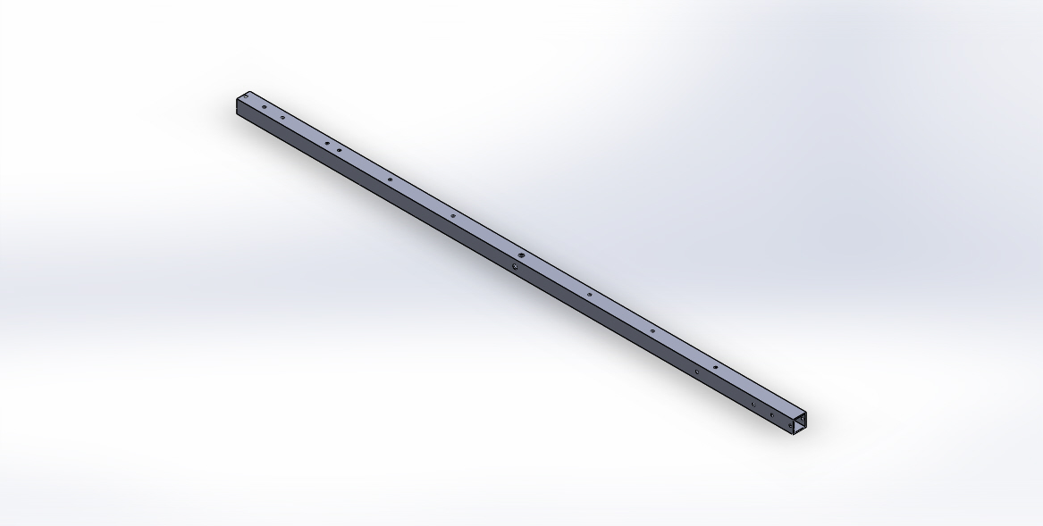
Figure-7: TRMS rod
The model is prepared with the help of solid works by creating the part diagram of steering knuckle. Many tools are used to design the model such as extrude, extrude cut, revolved cut etc. This type of design can be done in solid works with the help of tools they provide. Most of the time, we use extrude option so as to create the solid model. In order to remove the unwanted material, extrude cut is used more often.

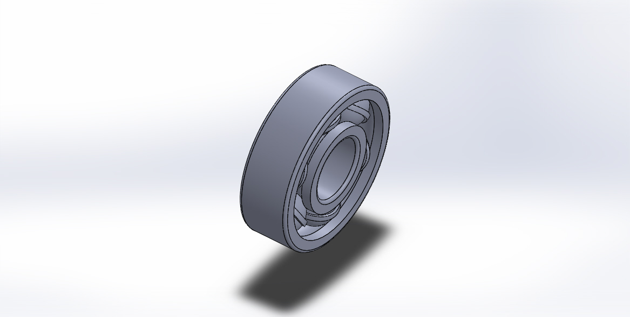
Figure-8: Bearing
For bearing cage we did Boss-Extrude, Cut-Revolve. Fillet, and then shell. Then the ball is done with the help of forming hemisphere and revolving and hence finally outer race and inner race is produced with the required diameter.

CHAPTER 4
ANALYSIS
4.1 ANSYS
ANSYS,Inc. is an engineering simulation software developer headquartered south of Pittsburgh in the South point business park in Pennsylvania, United States. One of its most significant products is Ansys APDL, a proprietary FEA program.
4.2 MATERIAL PROPERTIES
There are several materials used for manufacturing of TRMS Rod and TRMS Setup such as Stainless Steel, Titanium, Kevlar and Aluminum. But aluminum is proved to be cost effective. Titanium is dealt with proven best results but being expensive it is least preferred. Nowadays, automobile has put effort to use aluminum alloys as alternatives. Due to low weight of this material, it can reduce fuel consumption and CO2 emission. So as per survey the best study material is Stainless steel. Therefore properties of Stainless steel, aluminum, titanium and Kevlar are taken for analysis by applying their physical properties and are compared so as to prove which is better.

MATERIALS USED | YOUNG’S MODULUS  ( GPa) | POISON RATIO | ULTIMATE TENSILE STRENGTH  (MPa) | DENSITY  (N) | MODULUS OF RIGIDITY  (GPa)
Stainless Steel | 180 | 0.305 | 505 | 73.37 | 77.2
Aluminium | 69 | 0.334 | 290 | 27.468 | 27
Mild steel | 205 | 0.303 | 247 | 77.0085 | 79.3
Titanium | 110 | 0.32 | 434 | 44.145 | 41
Kevlar | 76 | 0.35 | 3600 | 13537800 | 19

4.3 ELEMENT TYPE
SOLID45 is used for 3D mesh model of solid structures of Hyper mesh. The element is defined by 10 nodes having 3DOF at each node: Translations in the nodal X, Y, Z directions. The element has plasticity, creep, swelling, stress stiffening, large strain capabilities. This element is used to define orthotropic material properties.
Input Summary
Element Name | SOLID45
Nodes | I, J, K, L, M, N, O, P
Degrees of Freedom | UX, UY, UZ
Real Constants | Hourglass control factor needed only when KEYOPT(2)=1.  Note-The valid value for this real constant is any positive number; default=1.0. We recommend that you use a value between 1 and 10.
Material Properties | EX, EY, EZ, (PRXY, PRYZ, PRXZ or NUXY, NUYZ, NUXZ), ALPX,  ALPY, ALPZ, DENS, GXY, GYZ, GXZ, DAMP
Surface Loads | Pressures:  face 1 (J-I-L-K), face 2 (I-J-N-M), face 3 (J-K-O-N),  face 4 (K-L-P-O), face 5 (L-I-M-P), face 6 (M-N-O-P)
Body Loads | Temperatures:  T ( I ), T ( J ), T ( K ), T ( L ), T ( M ), T ( N ), T ( O ), T ( P )  Fluences:  FL ( I ), F L( J ), FL ( K ), FL ( L ), FL ( M ), FL ( N ), FL ( O ), FL ( P )
Special Features | Plasticity, Creep, Swelling, Stress stiffening, Large deflection, Large strain, Birth and death, Adaptive descent
KEYOPT(1) | 0 - Include extra displacement shapes  1 - Suppress extra displacement shapes
KEYOPT(2) | 0 - Full integration with or without extra displacement shapes, depending on the setting of KEYOPT(1)  1 - Uniform reduced integration with hourglass control; suppress extra displacement shapes (KEYOPT(1) is automatically set to 1.).
KEYOPT(4) | 0 - Element coordinate system is parallel to the global coordinate system  1 - Element coordinate system is based on the element I-J side
KEYOPT(5) | 0 - Basic element solution  1 - Repeat basic solution for all integration points  2 - Nodal stress solution
KEYOPT(6) | 0 - Basic element solution  1 - Surface solution for face I-J-N-M also  2 - Surface solution for face I-J-N-M and face K-L-P-O (Surface solution available for linear materials only)  3 - Nonlinear solution at each integration point also  4 - Surface solution for faces with nonzero pressure

4.4 MESHING USING HYPERMESH
Hyper Mesh has advanced model assembly tools capable of supporting complex sub-system generation and assembly, in addition, modeling of laminate composites is supported by advanced creation, editing and visualization tools. Design change is made possible via mesh morphing and geometry dimensioning. Hyper Mesh is a solver neutral environment that also has an extensive API which allows for advanced levels customization.
The procedural steps are as follows:
The first step was to covert .SLDPRT to .IGS file format which is universal. This is done due to minimal data loss while transfer file.
The converted .IGS file is imported into Hyper mesh using Import command -> Import Geometry.

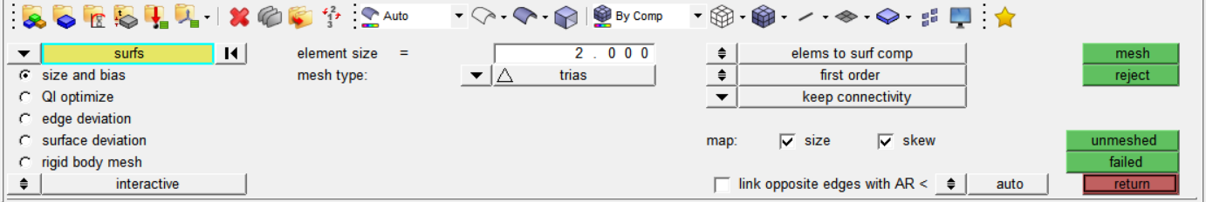
Figure- 9: Hyper mesh auto mesh panel
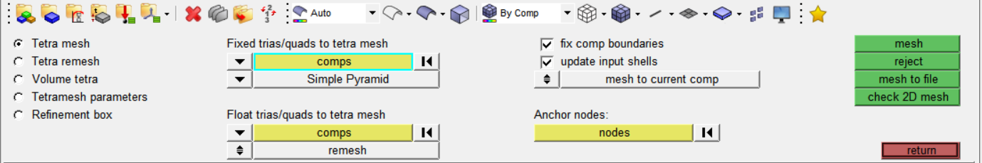
Figure- 10: Tetra mesh Panel
Using auto mesh panel, 2D TRIAS elements are created for each individual component with considerable number of nodes respectively.
Create new components for creating 3D mesh and set the component as Current. Using tetra mesh 2D TRIAS element are transformed into Tetrahedral elements.
While transferring 3D element for tetrahedral SOLID45 element is assigned.
For providing connectivity, nodes of each adjoining components are made to coincide with each other.
Now the 3D elements are exported/saved separately in compressed database format (*.cdb).
While exporting/saving elements the 3D elements are defined by its element type.
Create load collectors for conditions namely constrains and loads.
Select constrains as current load collectors, this is done to apply constrain to fixed supports.
By choosing constrain in analysis panel, and selecting the nodes which are to be fixed the constrains are applied.
Similarly, the process to apply loads at each node is divided equally and magnitude of each is provide after completion of procedure in analysis panel.
The file is then saved in compressed database format (.cdb).

The file is then taken to ANSYS MECHANICAL APDL 16.0.

4.5 STATIC ANALYSIS
To observe maximum stress produced in the TRMS Setup, model is subjected to extreme conditions on the basis of trial and error and static analysis is carried out in ANSYS Mechanical APDL 16.0. The loading conditions are as mention in the procedural steps.
To observe stress, strain, deflection in the setup the imported file was plotted with nodes and elements.
Then under Modelling, Material properties

4.6 STRUCTURAL ANALYSIS
The following results were obtained from ANSYS Mechanical APDL 16.0 for Aluminium, Kevlar, Stainless steel and Titanium.
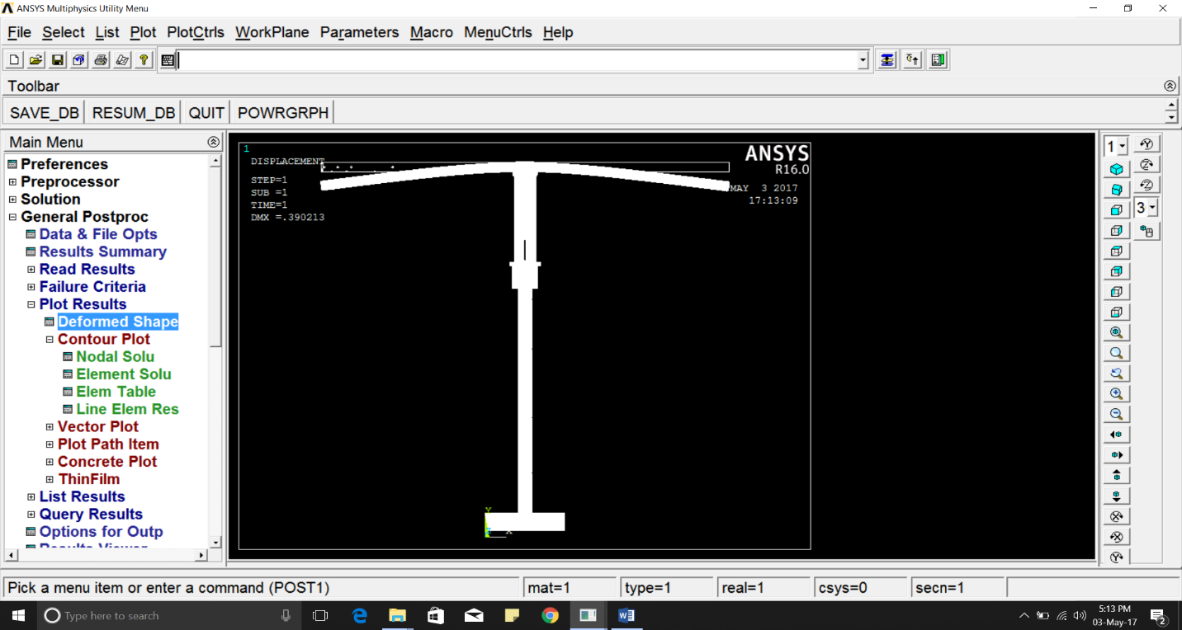
Figure-11: Deflection for Aluminium material
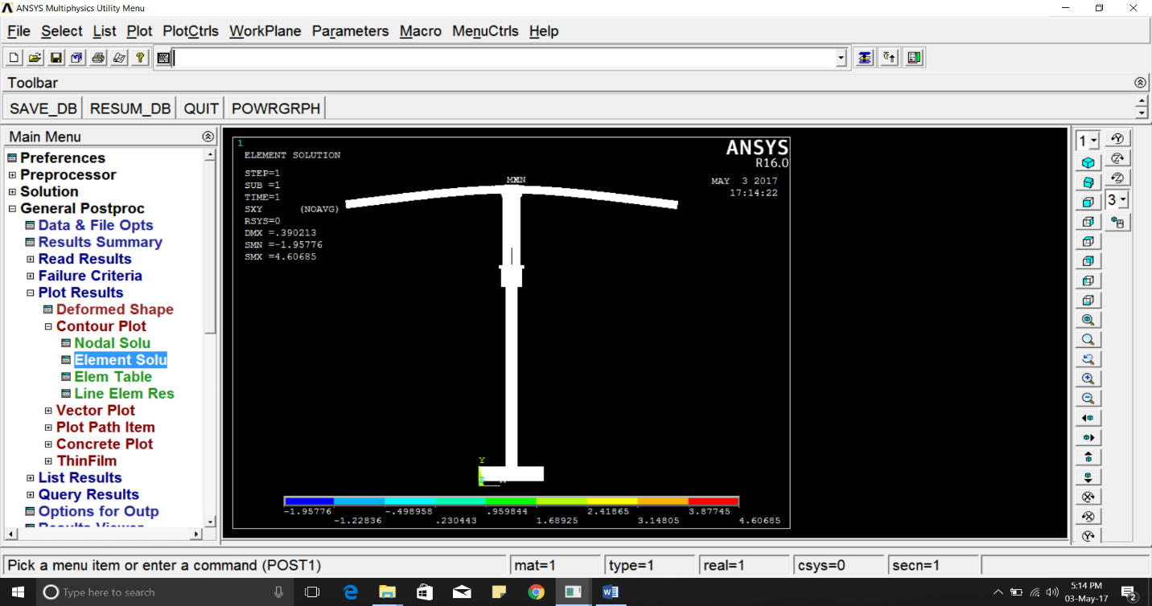
Figure-12: Shear stress XY for Aluminium.
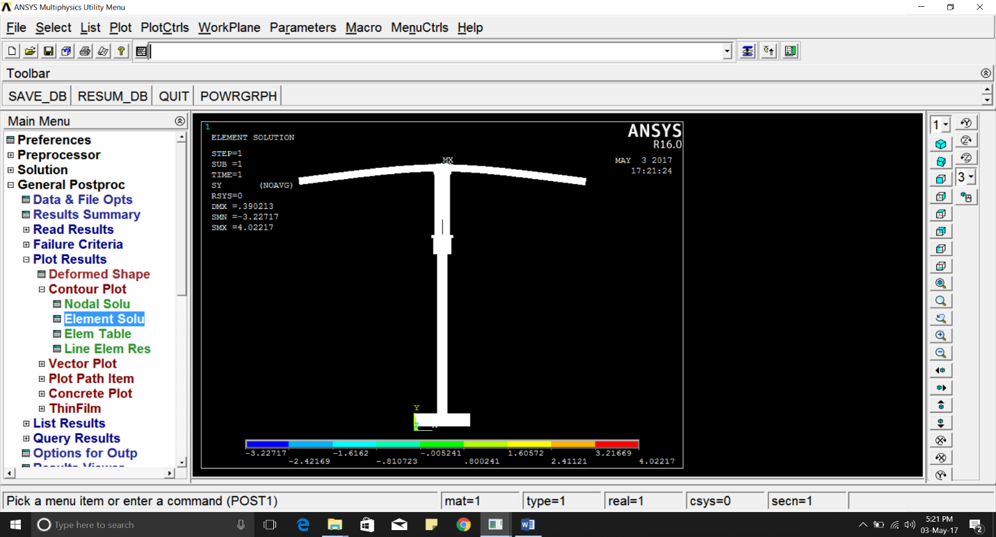
Figure-13 : Stress Y for Aluminium.
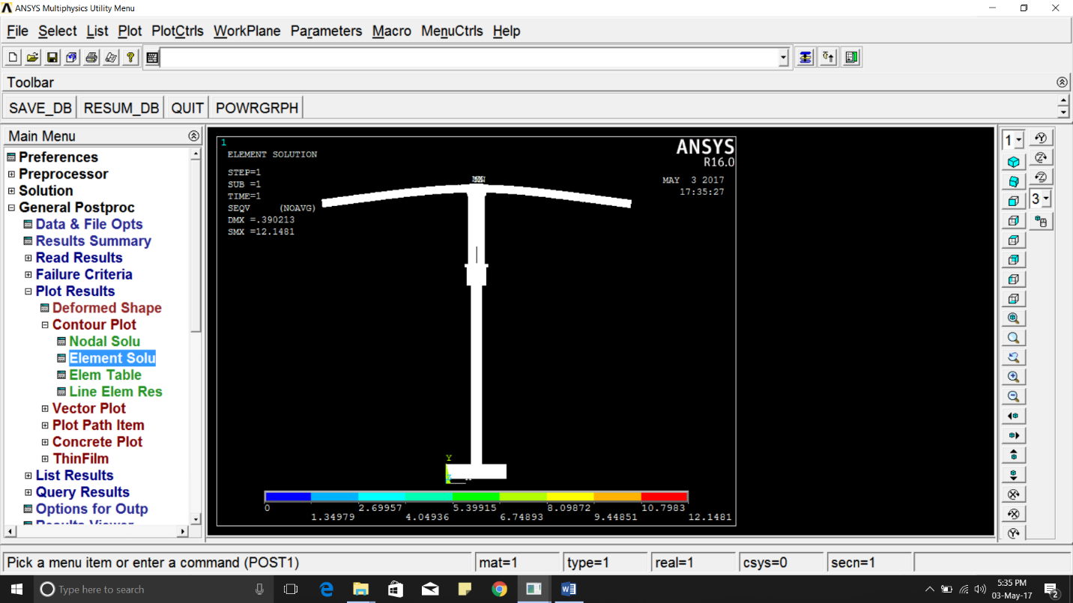
Figure-14: von Mises stress Y for Aluminium.

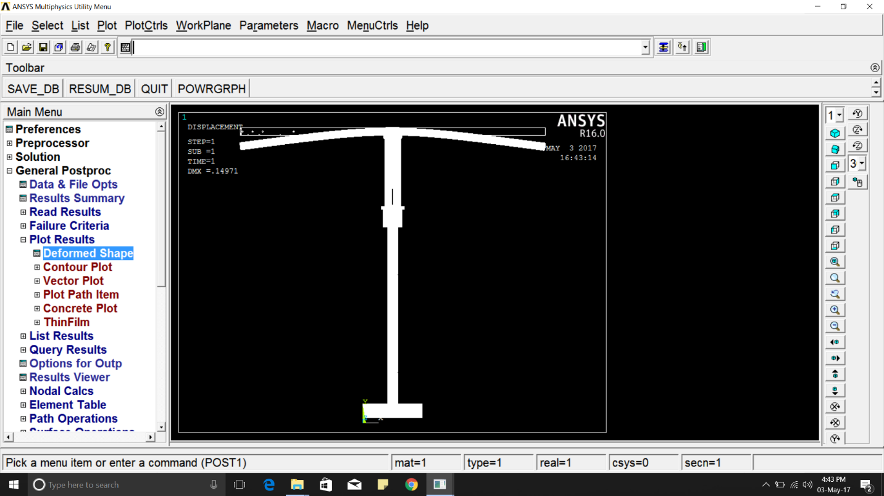
Figure-15 : Deflection for Stainless steel material
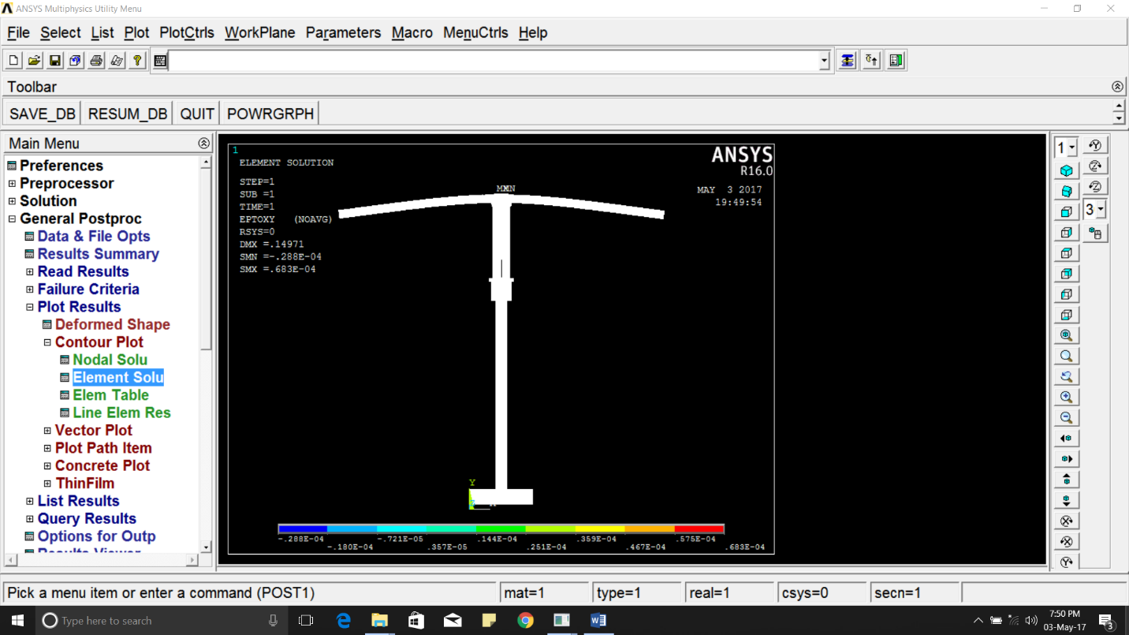
Figure-16: Shear stress XY for Stainless steel..

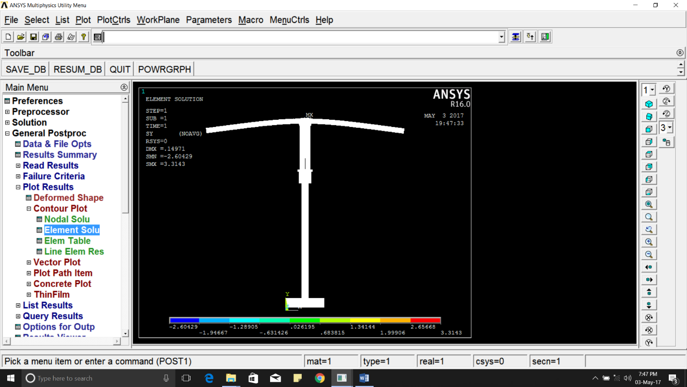
Figure-17 : Stress Y for Stainless steel.
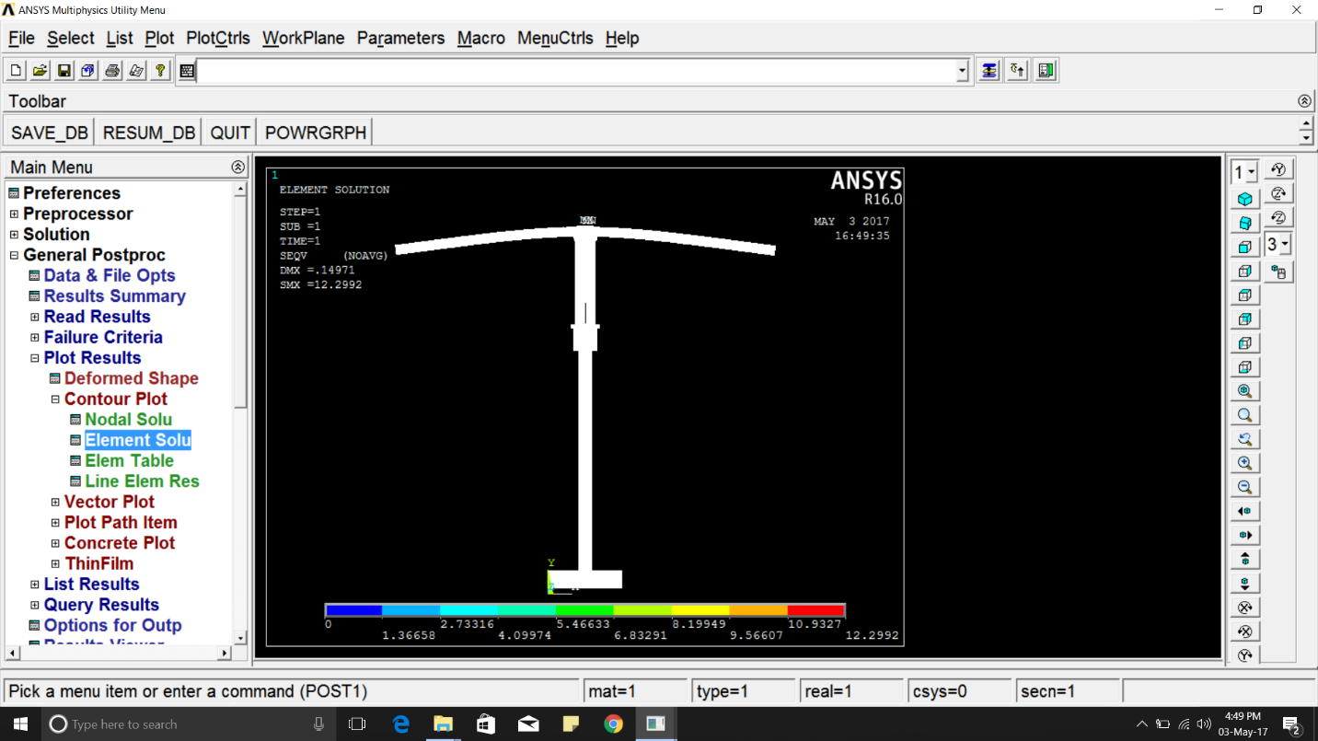
Figure-18 : von Mises Stress for Stainless steel.

THEORETICAL CALCULATIONS

DEFLECTION OF BEAM
CASE 1
GIVEN
W₁=W₂=W₃=W₄=5N
l=530mm, a=490mm, b=370mm, c=250mm, d=130mm
E=1.8*10⁵

W4 W3 W2 W1

d
c
b
a
l

FORMULA
y = W₁a³/3EI + W₁a²(l-a)/2EI +W₂b³/3EI + W₂b³/3EI + W₂b²(l-a)/2EI + W₃c³/3EI
+ W₃c²(l-c)/2EI + W₄d³/3EI + W₄d²(l-d)/2EI

I=(H⁴-h⁴)/12

SOLUTION
I = (25⁴-22⁴)/12 = 13030.75 mm⁴
y = 5*490³/ (3*1.8*10⁵*13030.75) + 5*490²(530-490)/ (2*1.8*10⁵*13030.75)
+ 5*370³/ (3*1.8*10⁵*13030.75) + 5*370*(530-370)/ (2*1.8*10⁵*13030.75)
+ 5*250³/ (3*1.8*10⁵*13030.75) + 5*250*(530-250)/ (2*1.8*10⁵*13030.75)
+ 5*130³/ (3*1.8*10⁵*13030.75) + 5*130*(530-130)/ (2*1.8*10⁵*13030.75)

y = 0.08 + 0.01 + 0.03 + 0.02 + 0.011 + 0.018 + 0.0015 + 0.0072.
y = 0.177 mm
CASE 2
GIVEN
W₁ = 5N, W₂ = 5N, W₃ = 10N, W₄ = 10N
l=530mm, a=490mm, b=370mm, c=250mm, d=130mm
E=1.8*10⁵

SOLUTION
I = (25⁴-22⁴)/12 = 13030.75 mm⁴
y = 5*490³/ (3*1.8*10⁵*13030.75) + 5*490²(530-490)/ (2*1.8*10⁵*13030.75)
+ 5*370³/ (3*1.8*10⁵*13030.75) + 5*370*(530-370)/ (2*1.8*10⁵*13030.75)
+ 10*250³/ (3*1.8*10⁵*13030.75) + 10*250*(530-250)/ (2*1.8*10⁵*13030.75)
+ 10*130³/ (3*1.8*10⁵*13030.75) + 10*130*(530-130)/ (2*1.8*10⁵*13030.75)

y = 0.08 + 0.01 + 0.03 + 0.02 + 0.022 + 0.037 + 0.003 + 0.0144 = 0.2164 mm.

SHEAR FORCE AND BENDING MOMENT
GIVEN
W₁=W₂=W₃=W₄=5N
l=530mm, a=490mm, b=370mm, c=250mm, d=130mm

W4 W3 W2 W1

130mm 120mm 120mm 120mm 40mm
F E D C B A

SOLUTION
SECTION BC

X B

x A

X

SF BM
Fx = -5N Mx = -5x Nmm
F_{B} = -5N M_{B} = -5*40 = -200 Nmm (x=40)
F_{C} = -5N M_{C} = -5*160 = -800 Nmm (x=160)
SECTION CD
X C B

160 A
x
X

SF BM
Fx = -5N-5N Mx = -5x -5 (x=160)
F_{D} = -10N Mc = -800 Nmm (x=160)
Fc = -10N M_{D} = -2000 Nmm (x=280)
SECTION DE

X D C B

280 A
x
X
SF BM
F_{X} = -5N-5N-5N M_{X} = -5x -5(x-160) - 5(x-280)
F_{D} = -15N M_{D} = -2000Nmm (x=280)
F_{E} = -15N M_{E} = -3800Nmm (x=400)
SECTION EF

X E D C B

400 A
x
X
SF BM
F_{X} = -5N-5N-5N-5N M_{X} = -5x – 5(x-160) -5(x-280) -5(x-400)
F_{E} = -20N M_{E} = -3800Nmm (x=400)
F_{F} = -20N M_{F} = -6400Nmm (x=530)

SHEAR FORCE AND BENDING MOMENT DIAGRAM
W4 W3 W2 W1

F E D C B A

BASE LINE

SHEAR -5N -5N
FORCE
-10N -10N
-15N -15N

-20N -20N

BENDING -200Nmm
MOMENT -800Nmm

-2000Nmm
-3800Nmm
-6400Nmm

CHAPTER 6
CONCLUSION
Initial model of TRMS is carried out for calculations of equivalent stress, strain and total deformation, by applying the physical properties of each material in ANSYS MECHANICAL APDL 16.0.
Analysis is done by taking single material at a time and applying their physical properties of each material in ANSYS MECHANICAL APDL 16.0. Since the material properties are unique the results obtained are also different. By the results we could compare the required equivalent stress, equivalent strain and total deflection of each material and identify which material yields better results.
We would like to conclude by saying our opinion on the project and its requirement along with the scope for future enhancement.
We studied the existing model to understand the loading condition, material constrains and structural variations. After finding that the existing prototypes of this model are unexplored in the mechanical domain. For example, front loading, structure and degrees of freedom are all constrained.
In our project we have tried to relate real life situation into a design that could be prototyped and studied. Our project focuses of study of stress, strain, shear, and deformation (deflection). The materials under study include Aluminium, Stainless steel, Kevlar and Titanium whose properties are unique. We have tabulated the results together in Table-2.
The results obtained through ANSYS APDL and mechanical calculation shows 5-10 % error which might open up scope for future correction, thereby enhancements.

CHAPTER 7
REFERENCE
M. Twin Rotor, System Manual, Feedback Instruments, Crowborough, UK, 2002.
M. Chen, S. S. Ge, and B. V. E. How, “Robust adaptive neural network control for a class of uncertain MIMO nonlinear systems with input nonlinearities,” IEEE Transactions on Neural Networks, vol. 21, no. 5, pp. 796–812, 2010. View at Publisher · View at Google Scholar
A. Boulkroune, M. M'Saad, and H. Chekireb, “Design of a fuzzy adaptive controller for MIMO nonlinear time-delay systems with unknown actuator nonlinearities and unknown control direction,” Information Sciences, vol. 180, no. 24, pp. 5041–5059, 2010. View at Publisher · View at Google Scholar · View at Zentralblatt MATH · View at Scopus
A. Rahideh, A. H. Bajodah, and M. H. Shaheed, “Real time adaptive nonlinear model inversion control of a twin rotor MIMO system using neural networks,” Engineering Applications of Artificial Intelligence, vol. 25, no. 6, pp. 1289–1297, 2012. View at Publisher · View at Google Scholar · View at Scopus
A. Rahideh, M. H. Saheed, A. Safavi, and J. C. Huijberts, “Model predictive control of a twin rotor MIMO system,” in Proceedings of the 21st International Conference on Methods and Models in Automation and Robotics, p. 2831, Międzyzdroje, Poland, 2006.
Y. Li, S. Tong, and T. Li, “Observer-based adaptive fuzzy tracking control of MIMO stochastic nonlinear systems with unknown control directions and unknown dead zones,” IEEE Transactions on Fuzzy Systems, vol. 23, no. 4, pp. 1228–1241, 2015. View at Publisher · View at Google Scholar · View at Scopus
Y. M. Li, S. C. Tong, and T. S. Li, “Hybrid fuzzy adaptive output feedback control design for uncertain MIMO nonlinear systems with time-varying delays and input saturation,” IEEE Transactions on Fuzzy Systems, 2015. View at Publisher · View at Google Scholar
J.-G. Juang, M.-T. Huang, and W.-K. Liu, “PID control using presearched genetic algorithms for a MIMO system,” IEEE Transactions on Systems, Man and Cybernetics Part C: Applications and Reviews, vol. 38, no. 5, pp. 716–727, 2008. View at Publisher · View at Google Scholar · View at Scopus
S. Tong and H.-X. Li, “Fuzzy adaptive sliding-mode control for MIMO nonlinear systems,” IEEE Transactions on Fuzzy Systems, vol. 11, no. 3, pp. 354–360, 2003. View at Publisher · View at Google Scholar · View at Scopus
S. C. Tong, Y. M. Li, and P. Shi, “Observer-based adaptive fuzzy backstepping output feedback control of uncertain MIMO pure-feedback nonlinear systems,” IEEE Transactions on Fuzzy Systems, vol. 20, no. 4, pp. 771–785, 2012. View at Publisher · View at Google Scholar · View at Scopus

